**Project Debugging Exercises**

Breakpoint

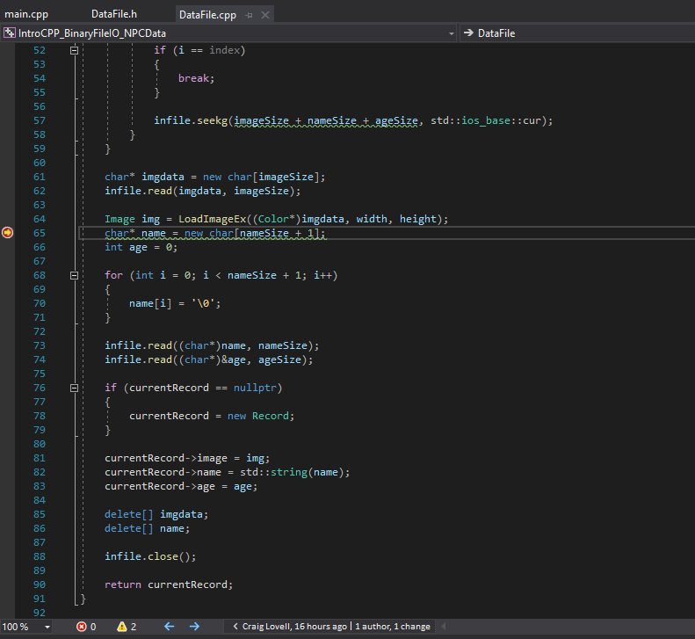

Callstack

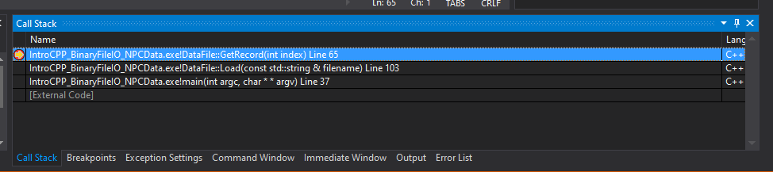

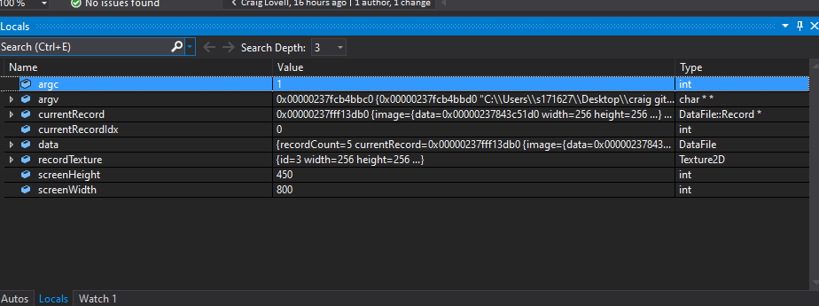Auto, Local and Watch Variables

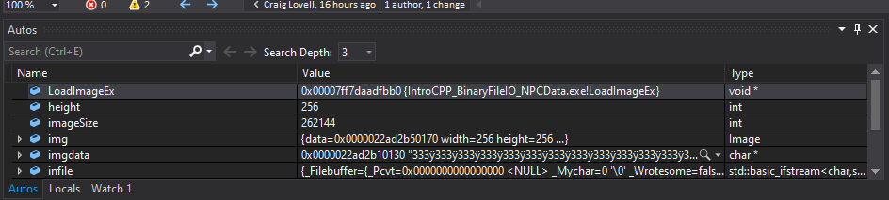

Keyboard Shortcuts

Step Over

Step Into

Step Backwards

Step Forwards

Step Out

Test 1

This is the code I created and edited to fix the crashing error when you get to the last index it now will reloop back to number 1 after you hit the end and try to go to the next and same with the start if you try to go back.

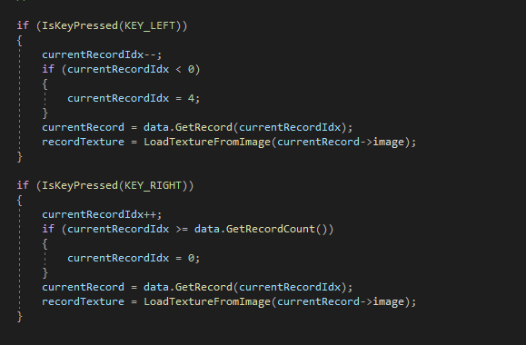

Test 2

This is the code I created to fix the name showing random characters what im doing is replacing the stuff after the name will null characters and this results like this look at picture 2

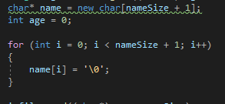

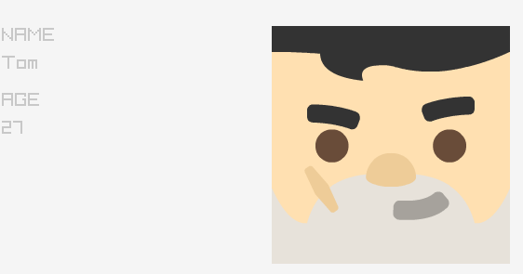

Test 3

This code makes the index load one by one and after its loaded and you move to the next it removes the previous one once you move past the current one

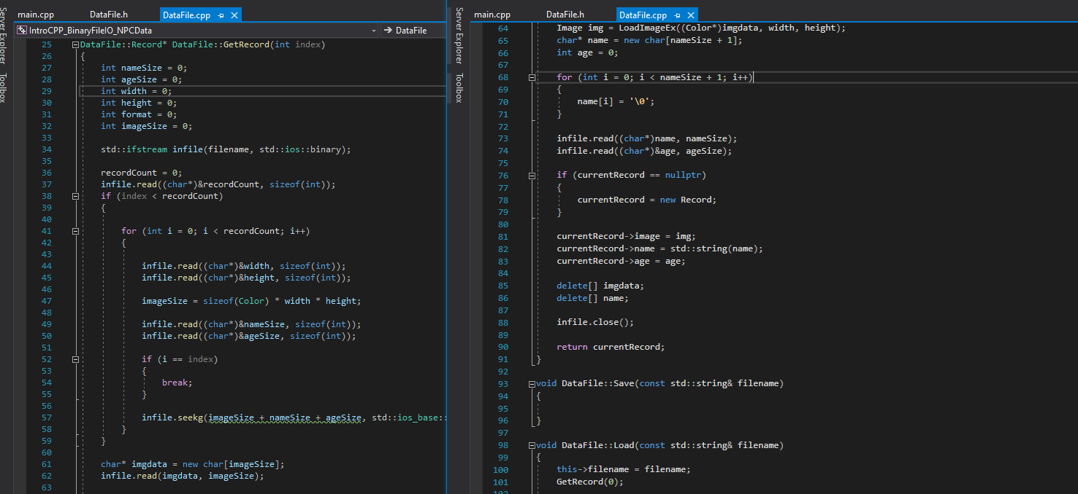

Report on How I tested work

I tested my work with comparing it to the old files and with multiple runs with altering the code to insure that it is working and doing what is asked with loading one at a time fixing the names and the crash and the end after the 5th one